Smart Public Restrooms

Team members:

M.SriHariPreetha B.Dharani

T. Sobhiya

K. Uva sri

Introduction:

|  |  |  |
| --- | --- | --- |
| |  | | --- | | Creating a smart public restroom project using IoT (Internet of Things) involves integrating various technologies to enhance convenience, hygiene, and maintenance. | |  |
|  |

Features:

1. **Smart Sensors:**Motion sensors to detect occupancy and trigger automatic door opening.Occupancy sensors inside stalls to determine usage and trigger cleaning alerts.
2. **Automatic Dispensers:**IoT-enabled soap dispensers and hand sanitizer stations that dispense based on usage and monitor refill levels.Smart paper towel and toilet paper dispensers that dispense in controlled amounts and signal when they need refilling.
3. **Water Management:**IoT-based faucets that provide touchless water flow control to conserve water.Water quality monitoring to ensure safe and clean water supply.
4. **Hygiene Monitoring:**IoT-connected restroom monitoring systems to assess cleanliness and report issues in real - UV-C disinfection systems to sanitize restroom fixtures during off-hours.
5. **Waste Management:**

Smart trash bins with sensors to detect fill levels and optimize waste collection routes. Recycling and waste segregation reminders for users.

1. **Energy Efficiency:**
   * Energy-efficient lighting controlled by occupancy sensors.
   * HVAC systems adjusted based on occupancy to save energy.
2. **Maintenance and Alerts:**
   * IoT-enabled devices that send alerts when fixtures malfunction or require maintenance.
   * Predictive maintenance algorithms to reduce downtime.
3. **User Experience:**

Mobile apps or touchless interfaces to provide information about restroom availability and cleanliness.

1. **Accessibility:**

IoT-powered features like voice-activated controls or braille signage for people with disabilities.

1. **Data Analytics:**

Collect and analyze data on restroom usage, water consumption, and maintenance needs to optimize operations.

1. **Security:**

Implement security measures to protect user privacy and prevent misuse of IoT data.

1. **Sustainability:**

Incorporate sustainable materials and designs to reduce environmental impact.

1. **Compliance:**

Ensure compliance with relevant privacy and accessibility regulations.

1. **Mobile App Integration:**

Mobile app integration for users to locate and access nearby smart public restrooms.

1. **Cost Analysis:**

Evaluate the cost savings and ROI (Return on Investment) achieved through IoT implementation, such as reduced water and energy consumption.

1. **User Education:**

Provide information to users about the benefits of using smart public restrooms and how to use the IoT-enabled features effectively.

FLOWCHART:

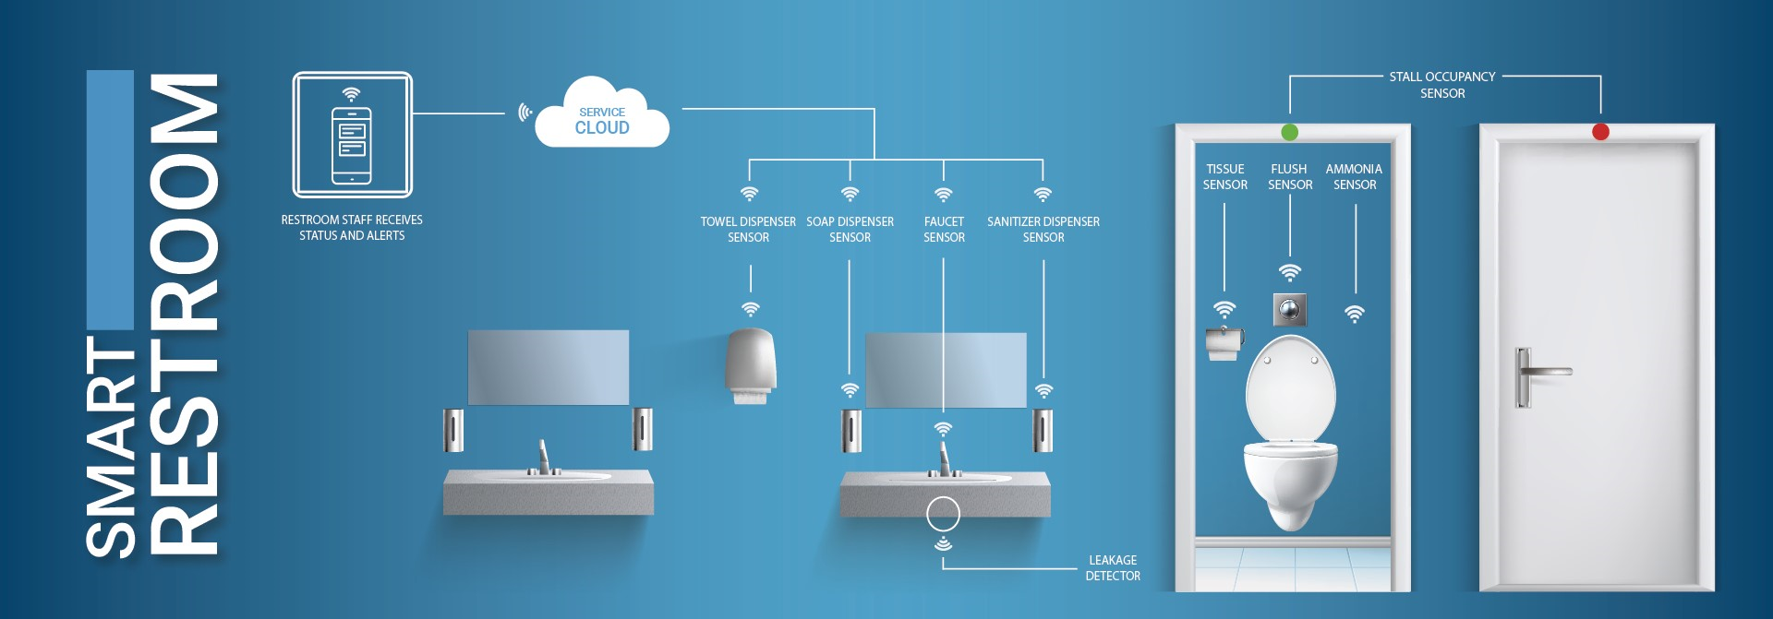

Conclusion:

A successful smart public restroom project using IoT should prioritize user experience, hygiene, sustainability, and operational efficiency while adhering to relevant regulations and privacy standards.

# Thank you